JOINT CHIEF PLAYBOOK
1997

All right, it’s time to think offensively. While defense is key to playing great college ultimate at a national level, offense is the beautiful side of the game. Right now, we work many times harder on offense than we have to. This playbook will help us in several ways. This will allow us to work with an offensive concept instead of random cuts and throws. We will learn how to exploit weaknesses on opposing teams. This playbook will also help us play better, more enjoyable ultimate.

SPECIFIC OFFENSIVE POINTS

Go hard to the disc. When you make a cut and the disc is thrown to you, that disc belongs to you! But it only belongs to you if you can get to it before anyone else. The weak may inherit the earth, but they won’t get the disc.

Be Patient with the disc. Every player has ten seconds to make a good throwing decision and use good mechanics. The best players around almost look like they’re playing in slow motion (Frauman, for instance), at least until you try to cover them. At the same time though, the first 2 seconds after the disc is caught the thrower is without a mark. Exploit this lack of defense when possible.

Make good decisions. Just like basketball players must make shot selections, ultimate players must make good throwing decisions. Most good throwers look downfield first (or for a quick give and go), for a long middle cut second, and then shorter handler cuts third (swings or dumps included). Good throwers also take open throws immediately. Patience is a virtue (see above), but a team that relentlessly keeps the disc moving to open cutters will not be stopped. Know your limits and play within them at tournaments…this will actually allow you to play in a zone (play beyond your ability) believe it or not. Practice is for pushing your limits (a little at a time) and becoming better with your throws and your decisions.

Take a Dump. Most people act a little ashamed when they take a dump (like that embarrassed look that a dog gets). I’m here to tell you to be proud of your dumps. Display them, show them off to your neighbors. Seriously though, we don’t have to get maximum yardage from every throw. Some of the most effective throws that demoralize defenses can be good dumps and swings or direct swings across the field. Remember that since cuts dictate throws in ultimate, a thrower can only take a dump if a cutter gives him a dump. Cutters should give a dump if the count gets scary high (above 6), you find yourself behind the flow with no way to clear without clogging, or to get the disc from a relatively poor thrower to a relatively good thrower. The best way to let a team member know about a dump is to say, “You’ve got a dump if you need it.”

Be aware of the situation. This is how we avoid double cutting, identify poaches, and get the disc to the open player. If you see an open player making a cut or about to make a cut, then don’t cut yourself. Let the open player get the disc and prepare to cut for him or for the player after that. Good offensive players are thinking two to three throws ahead of the present position of the disc (players like Joe often think two to three hundred throws ahead, which often leaves him thinking about the next game). Always be looking for the open area of the field. That’s were the next cuts should be made to.

Communicate. If the count gets above five and no cut is in site, then let your teammates know that downfield. Always count six, and at least one other number above six and below ten when the count gets high. If your defender poaches (hangs out in a throwing lane and not with you), yell “poach” and hurry to the most accessible open part of the field (this could be the endzone) so that you can get the disc in the next one or two throws. Throwers must take the responsibility of not throwing into waiting poaches (“make good decisions”). In addition, offensive players should repeat any pick call to the thrower loudly. Defensive players have a tendency to say “pick” instead of calling “pick” loudly because they would love to see a turnover.

Clear Effectively. This means clearing hard and fast. But clearing hard and fast right into the throwing lane will not win you many handler-type friends. Clearing up the sideline is okay, sometimes; and clearing up the middle is okay, usually; but there is no absolutely right way to clear. The most effective clears keep the throwing lanes open, allow other cutters to make good cuts, and sets you up for your next cut. As you clear, look at others around you, including the thrower. Sometimes a clear turns into an effective cut away from the disc, especially if your defender decides to poach (see the “option to buy” play). One more point…clear hard after you release the disc instead of standing and watching your beautiful waft. Think how much harder it is to cover someone who’s taken three steps by the time a player catches his throw (say , like, Bill Husk).

Know the Rules. This is more important than you might think. You must be able to think effectively when your defender yells “seveightninstal” quickly and you must make a call.

PLAY CALLING

1. We will make play calls on a stop of play: a turn near the goal line (which doesn’t lead to a quick score), a set up on an out-of-bounds pull or turnover, a stop of play due to a foul call. We will most often use a play call when we have the disc on or close to the opponents goal line, or on or near our own goal line, but always during a stop of play. One note: after a turn near the opponents goal line, we will either go for a quick goal (fast break), or we will stack it in the endzone and wait for a play call. Since our endzone stack will score about 95% of the time, go for a fast break score only when you judge the chance of scoring from picking up the disc yourself to be better than 95%.

2. On a stack, the handler closest to our own endzone will generally pick up the disk (unless he’s been throwing swill and calls himself off, or has a great match-up for a cut). The thrower will walk to the disk and make a play call before the disc is in play, preferably before he even touches the disc.

3. The stack must form quickly, so that the thrower can assess the situation and make a play call. The thrower/play caller is looking for the best match-up and not always the best player on our team. Our best offensive players will be covered by our opponents best defensive players, so what we want is the best mismatch available (that is, the mismatch working to our advantage).

4. At least one other player in the stack should repeat the play call to ensure that all Chiefs hear the play. To understand the play…read on.

5. If you realize that you are not in a play call…do not shut your mind off. First off, your defender does not know if you are cutting or not, so keep him on his toes. This way, he’s less likely to poach on the real play. Secondly, we only call one or two throws with a play call, to kick start the offense. Know who is likely to have the disc at the end of the sequence and what throws he likes. Then decide whether the next logical cutter is yourself…or maybe you just feel that karma thing going on and streak to the next spot (which might be the endzone).

DA PLAYS

Cut To the Disc (The T Play)

Example: “Fraggle Toronto Steg”

X’s are offensive and O’s are defensive players; _ represents the force; solid arrows are cuts and ---‘s are the disc paths (throws). Some words that are used commonly are Toronto, Turkey, Taco, and Topeka.
Here, Fraggle cuts to the disc and Steg is the second cutter if Fraggle does not get open. This play is called to mix up our offense (so the first two in the stack do not always cut first). We would like to take advantage of the best mismatch possible, or get the disc to a hot player.

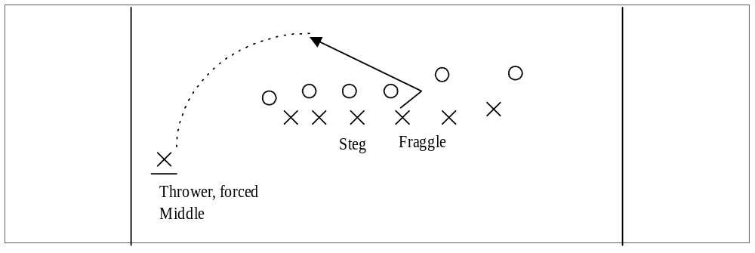

Break Force Cut (The B Play)

Example: “Lipscomb Baltimore Alexander”

The cutter can give an effective fake before making this cut. Throwers be careful; throwers often will call this play and then force a bad throw. Downfield players notice that once Lipscomb gets the disc on the break-force sideline, he will have a downfield throw with no mark and your man is playing on the middle field side of you. One person should make a downfield cut for Matt.

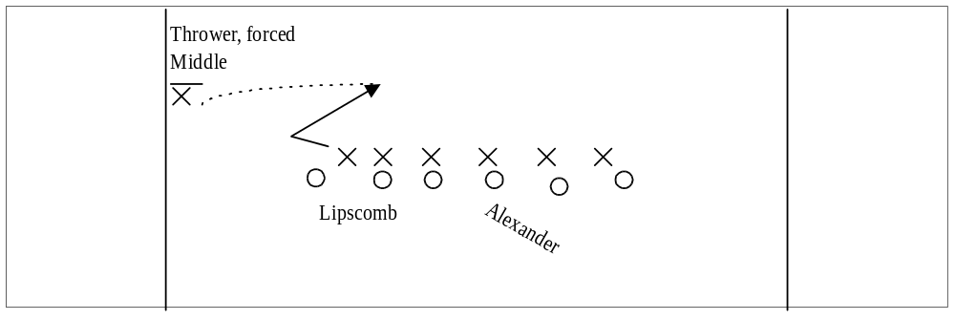

The Isolation Play (The I Play)

Example: Cleve Indiana Morris
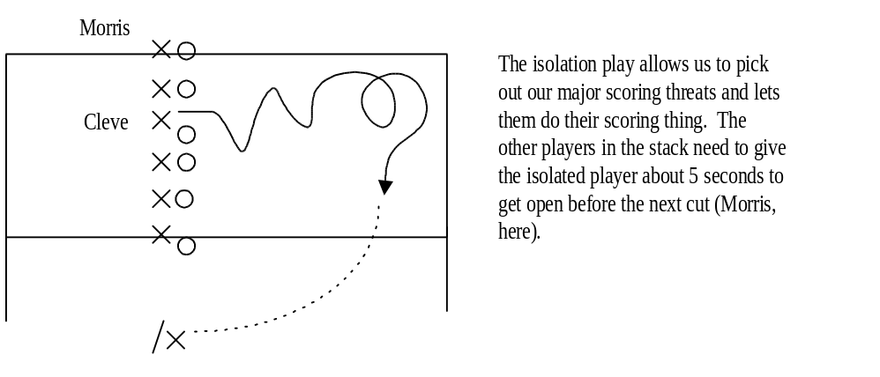

The Deep Cut (The D Play)

Example: Cheek Debbie Jason

This play often serves as a punt play. The important part is that Cheek cuts forward to draw his defender in closer. The line part of the cut gets the player past the end of the stack so no other defenders will help out. Jason makes the next cut if the deep cut is a bust. 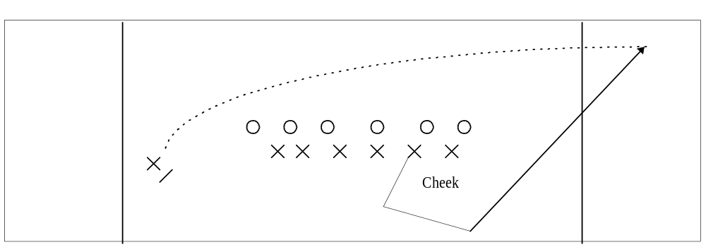
The Line Cut (The L Play)

Example: McDonald London Samsel

This offensive setup is called the L-stack, and will be used on most trap plays. Good calls from this setup are the L-cut (shown), the Break Force, or the To cut from someone down the stack. Right now we turn the disc over way too much on this setup trying to force a line throw. If a team gives you the immediate dump…take it! Then we can get a long swing across the field and the entire defense is out of position. If we do try a line cut, make the cut short. Most long, hanging line throws are intercepted by poachers down the line. If a play is not called, we will rely on the disc signals to tell McDonald what cut to make. If the thrower shows the disc label side out to McDonald, McDonald should make the line cut. If the bottom off the disc is shown then McDonald should go for the dump. The second man on the L goes in the opposite direction.

McDonald

Samsel

If the L-cut is called from a middle field position, then it means that the called cutter will make a cut away from the disc, to the forced side. On a personal note, the cut shown below is my favorite cut, but I never get to do it because other cutters don’t usually allow it to develop. (Ex: Borg Liberia Matt)

Borg
Matt

The Colorado State Play

Example: Colorado State
Gasper
“Colorado State” will not usually be called with names. It means #6 chooses his direction and #7 goes the opposite way. One or both will be open. On the stack up, if you can burn your man (no, I mean BURN your man), take him to the back of the stack and await the call for you.
Waters

The Give and Go (The G Play)

Example: Cheek Georgia Aerosmith
We got this play from a dirty old rat. Nobody expects the thrower to end up with the disc in the endzone on his own call, especially when the mark lunges for a point block in the opposite direction from which he will get schooled. It is up to the dump man (Cheek in this case) make sure the scoring cut is open before he throws the disc.
Also, notice the Y formation. We will call this formation well in advance to get set up properly. From the Y formation, we can run all of our other endzone plays.

Aeorsmith

Cheek

The Red Sea Play (Body of Water Play)

Examples: “Radka Red Sea Papa Bear” or “Radka Atlantic Ocean”

All of the players in front of the intended receiver must clear to the nearest sideline immediately (when the disc is tapped in). If not sure which way to go, then go to the break force side to get out of the way. When called in the open field, this play can get us 20-30 yards easily. If your man does not go with you, you are being poached, the play is abandoned and we use the poach. We will also use this play in the endzone. Players in front of the receiver in the endzone are expected to move faster than humanly possible to get out of the way (preferably to the break force side). We use any body of water to keep teams from picking up on the lingo, and because I think this play is powerful enough to split any body of water, and therefore, any defense.

Once Steg clears for the initial play, if Alex doesn’t get the disc, John is the next cutter in.

Radka
Steg

Three Musketeers

Example: Musketeers, Banta Pisan Lips

No graph is needed here. Normally called before a pull, this offense is strictly a three player give and go at least 2/3 of the way up the field. The other 4 players just keep backing up and stay busy enough to prevent your man from poaching. This offense is effective, quick, and is a great momentum shifter. Once we get close to the endzone, the forgotten four make good scoring cuts…and we score.
Toledo

Example: Chuck Toledo

This is a play for a score off the pull from Matt to Chuck back to Matt then to Chuck again. The play starts from a normal stack with one handler back as a dump. It starts with a 15-25 yd pass from Matt to Chuck on a comeback cut, cutting from the back of the stack on 45 degree angle toward the sideline, usually to the forced side. Matt cuts hard up the sideline (like he is going long), but as soon as he gets near Chuck, stops and swings back for the dump. The rest of the stack floods to the opposite side and short, so now every defender should be out of the way. Matt hits Chuck long to the endzone.
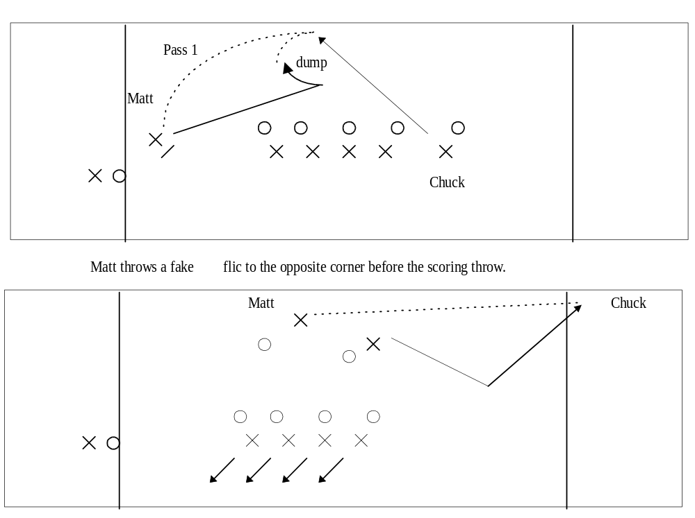

The Iceberg Play

Example: Banta Iceberg Brenda

This play is simple in conception, but effective by design. “Iceberg” simply means do not move until the disc is thrown. “Stand as still as an Iceberg, Grasshopper.” After the disc is in the air, Banta goes to the disc as hard as he can. The play can be called to either side, force or break, just in case someone on defense is big-time out of position. The default side is the break side. Hammers can be used on this play; inside outs and low backhands are recommend though.
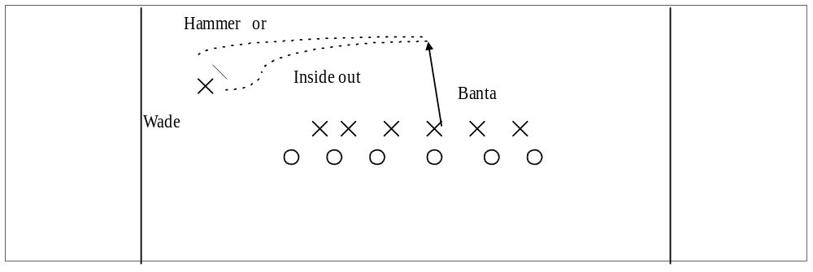
The Sweden

Example: Sweden

This play runs off a split formation and is similar to the “Swedish Variation” of basketball. When a pass is made to a handler near the sideline, it triggers the play. Wade cuts toward the middle of the field, receives the “fake” from the handler, then heads long. Frank cuts back toward the thrower once Wade vacates the space. The pass to Frank should be for good yardage, maybe 20 yards. Frank then looks for Wade streaking to the near corner of the endzone.

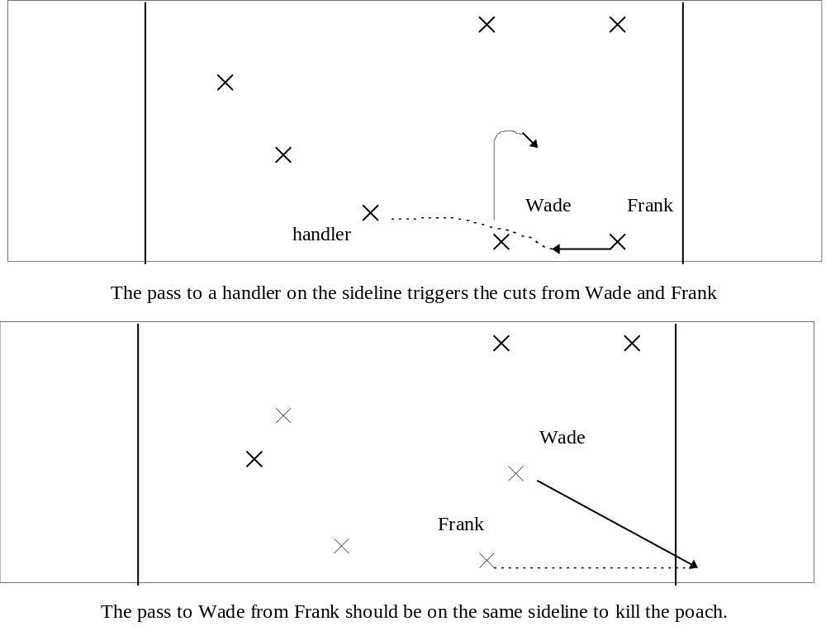

The Flood Play

Example: Flood right

The Flood play is a formation other than the traditional Stanford stack. From the fold play a Toledo or a Hot Man can be called. The players on the flood group to together close to the sideline, short of mid-field. The field has now been left wide open for the handlers to work with. If the play breaks down the players should default to the stack in the middle of the field.

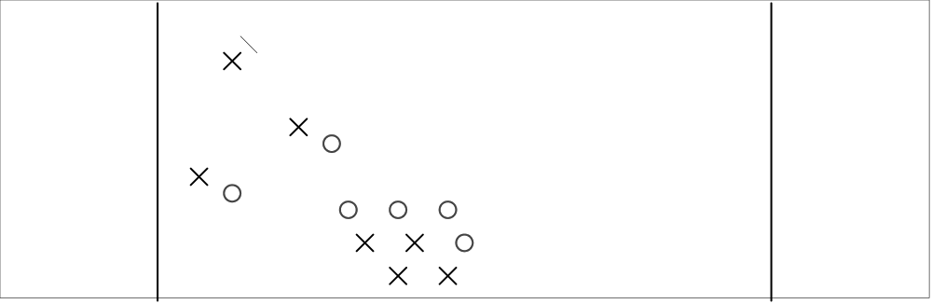

The Option to Buy Play

Example: Lipscomb Taco with an Option to Buy

The advantage that the offense has over the defense is that the offense knows what is about to happen. Therefore, the offense has a step on the defense when the disc is put into an area. This play makes use of this inherent advantage. When a Line, To, or Break play is called, “option to buy” can be added to the end of the play. In this case, the To play has been called with Matt. The “option to buy” extension simply tells Matt that if his cut is shut down on his way in, then the disc will be thrown over his shoulder to the wide side of the field. Below, Matt started his cut on the top of the diagram. Naturally, there is an open area in the bottom of the diagram, so that is where the disc should been thrown. Also, Matt’s momentum is “down”, so putting the disc to the force side is an easier cut for Matt. Note, if Matt is open on the regular To cut, then hit him with the disc. This play is about moving the disc, not big yardage. Also note that this play is much easier to run to the flic side.

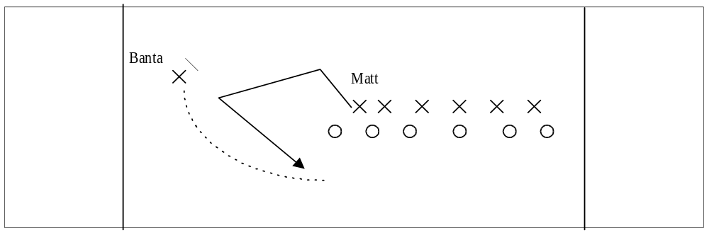

The Little L Play

Example: Little L

This is an endzone play, designed to give the defense another look. The Little L refers to the shape that the offensive players stand in so that they are out of the way. This play is a basically a hot-man in the endzone. If the play is initially stopped, Pisan, Matt, and Banta just run a hot-man until they score.
It is important that Pisan cuts away from the corner so his man won’t poach and intercept the throw to Matt.

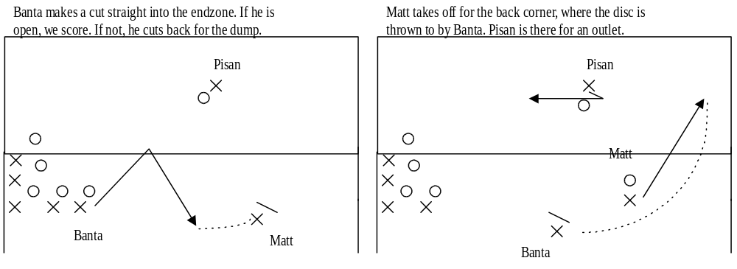

The Box Car Play

Example: Box Car Joint

This play is the Sweden in the endzone. But the thrower decides which side of the endzone to throw to by yelling Joint or Chiefs. Joint is to the thrower’s left side, and Chiefs is to the thrower’s right side. In this situation Matt’s first look is to Justin. If Justin is not open, then Matt looks for Jason cutting to the back corner. It is important that Steve cuts hard away from the play so his man won’t poach.

